

#### Assignment Cover Sheet

|  |  |  |  |  |  |  |
| --- | --- | --- | --- | --- | --- | --- |
| **Student name:** | **Evandro Gomez Quintino** | | | | | |
| **Student number:** |  | | |  | | |
| **Faculty:** | **Computing Science** | | |  | | |
| **Course:** | **BSC-HGP** | | | **Stage/year:** | **3** | |
| **Subject:** | **HCI & GUI Programming** | | | | | |
| **Study Mode:** | Full time |  |  | Part-time | **X** |  |
| **Lecturer Name:** | **Alex Cronin** | | | | | |
| **Assignment Title:** |  | | | | | |
| **No. of pages:** |  | | |  | | |
| **Disk included?** | Yes / No |  |  |  |  |  |
| **Uploaded to Moodle?**  **Additional Information:** | Yes / No  (ie. number of pieces submitted, size of assignment, A2, A3 etc) | | | | | |
|  | | | | | |
|  | | | | | |
| Date due: | **28/10/2019** | | |  | | |
| Date submitted: | **28/10/2019** | | |  | | |
|  | | | | | | |
| **Plagiarism disclaimer:**  *I understand that plagiarism is a serious offence and have read and understood the college policy on plagiarism. I also understand that I may receive a mark of zero if I have not identified and properly attributed sources which have been used, referred to, or have in any way influenced the preparation of this assignment, or if I have knowingly allowed others to plagiarise my work in this way.*  *I hereby certify that this assignment is my own work, based on my personal study and/or research, and that I have acknowledged all material and sources used in its preparation. I also certify that the assignment has not previously been submitted for assessment and that I have not copied in part or whole or otherwise plagiarised the work of anyone else, including other students.*  **Signed: Date: 28/10/2019** | | | | | | |

## 

## Please note: Students MUST retain a hard / soft copy of ALL assignments

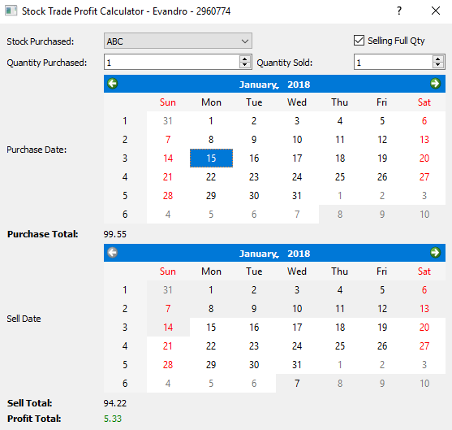Evandro’s Stock Trade Profit Calculator

**The program**

The following document presents a series of design choices, which were taken in order to provide a better understanding for the user when accessing and using the program. This way, making easier his experience while using the calculator to check the profits of a specific Stock selected.

Starting with the menu, user can select stocks by clicking in a dropbox which contains a pre-selected list of stocks loaded from a CSV file. The SpinBoxes “Quantity Purchased” and “Quantity Sold” shows the quantity of stocks that are being traded and the CheckBox “Selling Full Qty” is automatic checked when running the program, but user can just uncheck this option and so be able to reduce the quantity of stocks sold.

This feature allows user to be able to simulate different scenarios where a different quantity of stocks is sold.





As per above, the application will have the checkbox checked when opening the program. Setting this way, the selling quantity to be equal as per the Quantity Purchased.

When user uncheck this box, he will be allowed to change the Selling quantity from the spinbox, allowing this way the same to visualize how much profit he would adquire when selling partial quantities of stock.

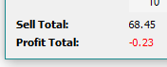When printing the results, the calculator has the Totals and Profits in bold, allowing this way a better design for the user who can easily visualize the main fields and their results.

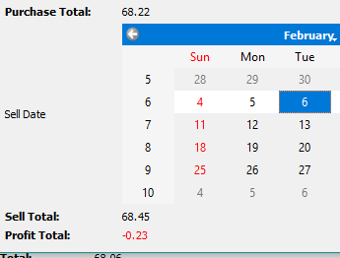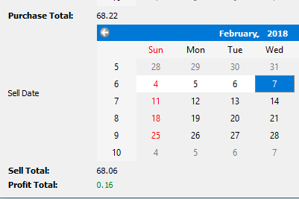

Depending of the Profit result, the same will print the value using the colour ‘red’ or ‘green’. If the result is negative, meaning that the user has lost some values when selling the stocks, the result will be set to a red colour.

When the same got some profit after selling a specific quantity of stocks, the result will be set to a green colour.

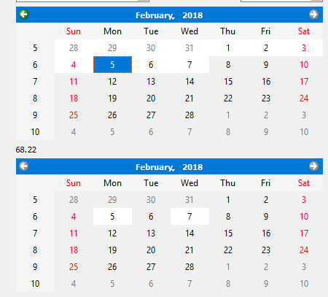In order to avoid incorrect selling dates by the user, the calendar date selection was modified. So, when selecting the buying date, the minimum range for the selling calendar is modified to start from the buying date. Example:

User selects buying date 5/12/2018, so the dates available for selling will be any date in the future, starting from the buying date.

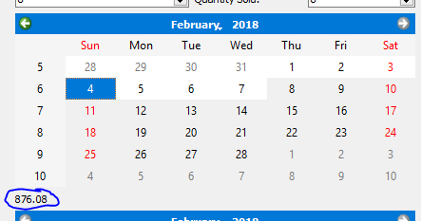When selecting any day during the weekend for purchase or selling, the program will automatically set the value to be populated from the next Monday. Once the weekends in the CSV isn’t filled with close values.

**Design**

Starting by the buttons, the combo-box was selected because is the best way to present to the user a list of different values. Also allows the same to use the keyboard and select the first letter of the desired value that we are looking for.

Because the stock is the main object of our program, the combo box has its location set to the top left corner. Allowing a better understanding from where user should start.

The “Selling Full Qty” was selected to be a checkbox because the main idea of the button was to be something to represent the activation or deactivation of a function. Its position was selected to be on the top right corner because when starting the program, it will be always activated (checked) and so the user doesn’t need to worry about this function every time.

Both “Quantity Purchased” and “Quantity Sold” are spinboxes, which allows user to type directly the desired value or even use the mouse to increase/decrease the value. Because both have the same concept, I have chosen to keep them in the same level and just before the calendar.

The fonts I have kept the same as default and just changed the ones related to total amounts to bold. This way user can easily check the main topics of the program that will return some value: “Purchase Total”, “Selling Total” and finally “Profit Total”.

Another way to help user to understand the result and easily identify if the same is getting profit or not, I have applied the colours red and green for the font result of “Profit Total”. This way user can just change the dates and by the colour identify if we have a positive or negative result.

The colour green and red were selected because human has a pre-concept that these colours are related with positive values (green) and negative values (red)

**Missing Features**

* The CSV file doesn’t contain values for the bank holidays (15/01/2018 for example). I was trying to do some check and any value equals to “none” print some message to the user, but I couldn’t make the check work properly.
  + When selecting weekends or bank holidays, I thought to implement an ErrorMessageBox, but not sure if would be the better design with boxes always pop-upping so I quit this idea.
    - Tried to find some way on the internet to show prompt texts but couldn’t find a good reference.
* I was trying to change the calendars colours for selecting, but the forums were talking about redesigning all the widget in order to change something like that.
* I tired to add a Button called “Graphs” , just after stocks selection and the intention would be to click and open a new window containing the Graph related with the selected stock, but unfortunately I had to cancel my idea.